- Problem
  - For the Mizkan account, there are two monthly performance PPT reports that are 24 slides each. The analysis and charts that populate the decks are simple/repetitive yet tedious to produce. In a past effort to reduce the number of slides, a supplemental excel file is sent out with several breakouts.
Technical Deck content: 42% of slides
      - Performance table (6 metrics) by 2 date ranges (CTD & MTD) compared to individual benchmarks
      - Bar graph of audience by IVR, with an overlaid IVR trendline
      - Trend graph of IVR WoW, broken out by device
      - Trend graph of IVR WoW, broken out by Image
      - *Tricky/Tedious Part* Image matrix (3x2) of top performing DCO images by CTR, by 6 audiences repeated and separated into individual slides (25% of the deck)
Reporting Deck content: 16% of slides
      - Executive summary of the reporting date range’s performance
      - Optimization log
      - DCO targeting breakout
Filler/Miscellaneous intro, agenda, separation slides: 42% of deck
      - Reusable static content
- Area of Opportunity
  - Automate as much as possible.
    - Foreseeably, all the Technical deck and Filler content (84% of deliverable) seem to be plausible given the data sets using a mixture of Seaborn, Matplotlib and Pandas libraries.
- Course of Action
  - Start with Technical deck in descending order – starting with “Problem 1.1.” and finishing with “Problem 1.5” which requires the most effort from the analyst.
    - 1.1 would require a pivot table with hardcoded benchmarks?
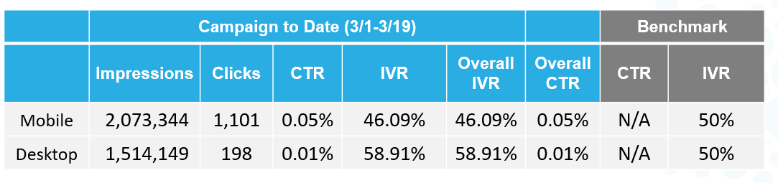
    - 1.2 – 1.4 would require Matplotlib & Seaborn to reproduce the graphs
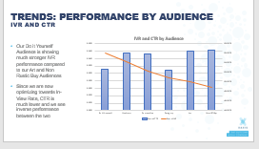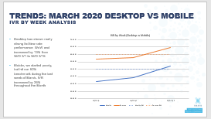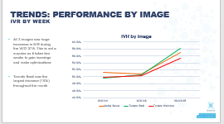
    - 1.5. would require an image library to store and conditionally reference the array of images to populate the matrix.
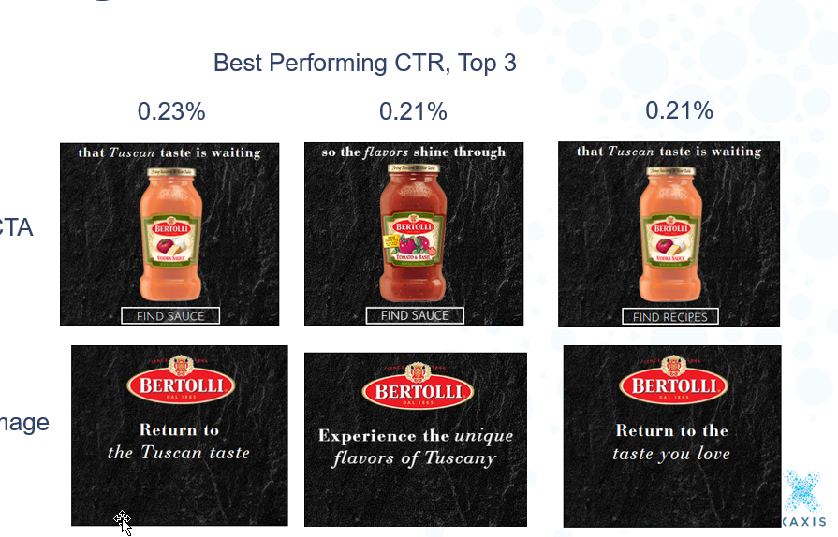 (x6)
    - Convert images/graphs to PPT slides using the “python-pptx” library
- Big Picture
  - Assuming all the above is plausible in the given timeframe,
    - add in simple conditional text boxes to the technical slides
    - add in filler slides
    - export as PPT and type out executive summaries
    - optimize and repeat for other advertisers

